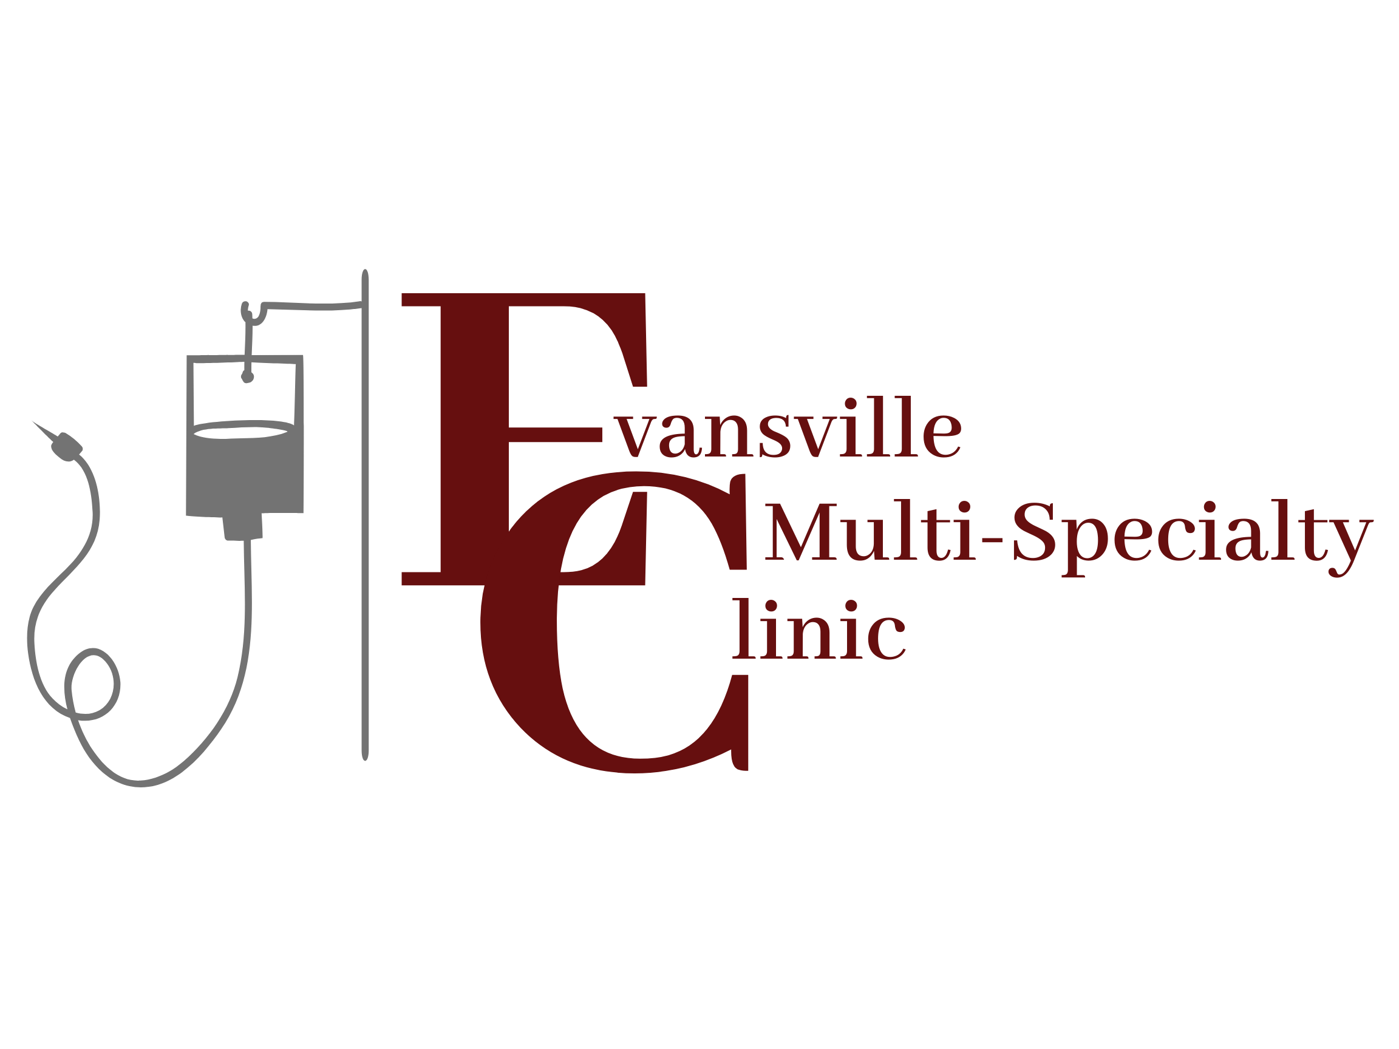

Prescription Policy

Our policy is in place to protect both the patient and the prescribing provider. This policy is for every patient that received any prescription from any provider in our office. Please read and initial your understanding below.

- All Prescription requests should be called to your pharmacy and will be refilled within 48 hours. Contact pharmacy 48 hours before you are out medication, we do not guarantee same day refill request
- If you have no refills left on your prescription, please contact pharmacy where your prescription needs to be refilled and have them fax a refill request to the office. PLEASE CONTACT YOUR PHARMACY FIRST
- We do NOT refill prescriptions on weekends and days the office is closed for Holidays
- For your convenience, call your pharmacy before going to be sure they have the medication ready for pickup
- Evansville Clinic providers will not fill prescriptions for patients not seen in the past 90 days by a clinic provider.
- USING ONLY ONE LOCAL PHARMACY THAT IS DETERMINED WHEN SIGNING THIS POLICY. ANY CHANGE IN PHARMACIES MUST BE DONE IN WRITING BEFORE ANY REFILLS WILL BE SENT.

Initials: ______

ACKNOWLEDGEMENT OF PRESCRIPTION POLICY

Date: _________________

I’ve read and understand Evansville Clinic’s policies regarding prescriptions. I agree to the terms involved in the prescription policies and violated or I choose not to adhere to these policies to these I am risking termination from this clinic, I also understand that I must choose a pharmacy at this time and will not switch the pharmacy unless I submit written request.

Pharmacy: ____________________ Location:_______________________

____________________________ ______________________________
Patient’s Printed Name Patient’s/Guardian’s Signature

